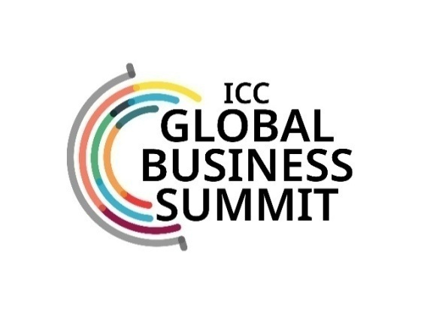

Day One - 18 September 2026

0900–1000 Hrs | Registrations & Networking over Tea/ Coffee
1000–1100 Hrs | Opening Session  Speakers – ICC Office Bearers; Industry Leaders, Senior Govt. functionaries
1100 – 1130 Hrs | Networking break
1130 – 1300 Hrs | Concurrent Sectoral Sessions
1130 – 1300 Hrs | Partner Country Session | Defence, Aero & Space | Metals & Minerals | 11.45 – 12.30 Hrs  State Government Session  (45 Minutes)
12.30-13.15 Hrs
State Government Session
(45 Minutes)

1300 – 1400 Hrs | Networking Lunch
1400 – 1530 Hrs | Concurrent Sectoral Sessions
1400 – 1530 Hrs | Sports Management | Mobility, Infra & Supply Chain- | Water Management & Circular Economy- | Country Session  (45 minutes)
State Govt. Session
(45 minutes)
1530 – 1545 Hrs | Logistical Break
1545 – 1715 Hrs | Concurrent Sectoral Sessions
 | Green Tech & Energy- | Indian Start Up Story | Partners Country Session | India-Middle East-EU Eco. Corridor
1715 Hrs | Networking Hi-tea
1745 – 19.15 Hrs | Healthcare & Pharma |  | Family Business Session
19.15-20.15 Hrs | Indian Musical Performance
2015 Hrs | Cocktails & Dinner
End of Day 1

18th – 19th September 2026 | Taj Palace, New Delhi

Day Two - 19 September 2026
0900–1000 Hrs | Registrations & Networking over Tea/ Coffee
1000–1100 Hrs | Opening Session  Speakers – ICC Office Bearers; Industry Leaders, Senior Govt. functionaries
1100 – 1130 Hrs | Networking break
1130 – 1300 Hrs | Concurrent Sectoral Sessions
1130 – 1300 Hrs | Chemicals & Petrochemicals- | Entertainment Industry | BRICS – Emerging Opportunities | 11.45 – 12.30 Hrs  State Government Session  (45 Minutes)
12.30-13.15 Hrs
State Government Session
(45 Minutes)

1300 – 1400 Hrs | Networking Lunch
1400 – 1530 Hrs | Concurrent Sectoral Sessions
1400 – 1530 Hrs | Financial Services & Fintech | Creative Economy | Agriculture & Food Processing | Country Session  (45 minutes)
State Govt. Session
(45 minutes)
1530 – 1545 Hrs | Logistical Break
1930 Hrs | Valedictory Session  Speakers – ICC Office Bearers; Industry Leaders, Senior Govt. functionaries
 | Tea/Coffee
Conclusion of the Summit

